Section 7
Implementation
The revision of the Lake Elsinore and Canyon Lake nutrient TMDLs includes implementation requirements designed to continue progress toward returning water quality to a reference condition for each lake segment. For almost two decades, a combination of watershed and in-lake controls have been implemented by individual organizations or through collaboration by multiple agencies. This section evaluates water quality improvements achieved from implementation of these controls and compares them with potential nutrient reductions from different sources to determine whether enhancements to existing measures and/or supplemental projects are needed for each lake segment to comply with WLAs and LAs or in-lake response targets established in the revised TMDL. Based on the outcome of this analysis, a TMDL implementation program was developed as described in the following sections:
- Section 7.1 – Reasonable Assurance Analysis (RAA) Approach: Implementation of water quality controls is needed to return each lake segment to a condition approximated for a reference watershed. This section provides the framework for demonstration of compliance with the revised TMDL through ongoing implementation of existing controls and incorporation of supplemental projects as needed.
- Section 7.2 – Review of Past and Present Water Quality Control Efforts: Water quality control activities and studies have been ongoing in the San Jacinto River watershed for many years. The outcomes from these varied efforts has led to a comprehensive scientific understanding of the characteristics and dynamics of Lake Elsinore and Canyon Lake. This section summarizes findings from prior water quality alternatives analyses and describes existing projects that have been implemented to date. In addition, the models developed for the TMDL’s source assessment and linkage analysis (Sections 4 and 5, respectively) are used here to quantify expected load reductions and the in-lake water quality response from ongoing implementation of existing projects. Based on the outcome of this analysis, this section presents the scientific basis for estimating future water quality benefits that will be accrued from the continued implementation of existing water quality control efforts.
- Section 7.3 – Supplemental Project Concepts: The RAA shows that enhancements to existing controls or new supplemental projects may be needed in all three lake segments to meet the revised TMDL numeric targets. This section provides an overview of potential supplemental projects for water quality improvement that could be considered for implementation in the future. Project concepts are described briefly and evaluated based on the type of benefits expected, applicability to each lake segment, technical feasibility, and order of magnitude cost.
- Section 7.4 - Program of Implementation: This section describes the phased implementation framework that began with the adoption of the original nutrient TMDLs and continues under the revised TMDLs. Moving forward, the program of implementation includes a list of implementation actions, milestones for completion and entity (ies) responsible for their implementation. The program of implementation is intended to ensure continued application of existing water quality controls (modified as needed), timely development of supplemental project plans (where needed), completion of targeted studies recommended to further validate the scientific basis for the TMDL revision, required revisions to existing waste discharge requirements and management plans, and execution of an appropriate surveillance and monitoring program.

7.1 Reasonable Assurance Analysis Approach

7.1.1 Framework
Implementation actions are required to return water quality in Lake Elsinore and Canyon Lake (Main Lake and East Bay) to conditions representative of a reference watershed condition. The TMDL numeric targets are expressed as CDFs of expected chlorophyll-a, DO, and ammonia in each lake segment for a reference watershed condition. Multiple pathways exist to achieve a range of lake water quality in the future; however, two general strategies are being employed: either (1) reduction of external nutrient loads to achieve WLAs and LAs and in turn response targets, or (2) implementation of water quality controls that directly affect the response targets in the lakes.
Figure 7-1 illustrates the two general implementation strategies employed to achieve water quality that meets the TMDL numeric targets. Existing and ongoing implementation activities for each lake and their respective watersheds have spanned both of these strategies, including (a) implementation of external nutrient controls; and (b) application of direct controls to manage algae, nutrients, oxygen, and/or hydrology within the lakes, where it is infeasible, impracticable or unreasonable to rely on source control as the primary water quality management tool.
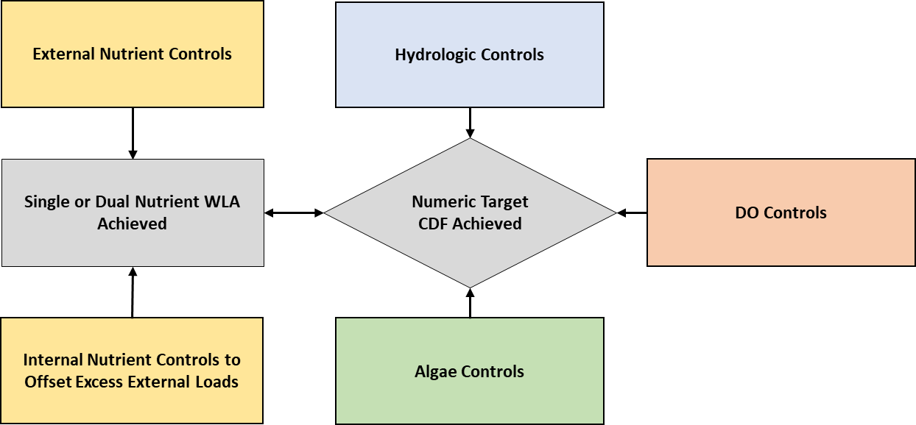
Figure 7-1. Alternative Pathways for Implementation Actions (colored boxes) to Achieve Compliance with TMDL Numeric Targets

7.1.2 Canyon Lake RAA Approach
In Canyon Lake, the RAA compares current nutrient loads from the watershed (see Section 4) with allocations applicable to a reference watershed (Section 6) to determine the excess nutrient loading to the lakes that should be reduced by either source controls or by offsetting internal loads. This nutrient mass-based RAA strategy is sufficient to prevent “excess algae growth” in Canyon Lake. Section 7.2.4.1 below establishes a nutrient-focused RAA for phosphorus in Canyon Lake as the means to estimate the amount of alum that may be applied to effectively reduce internal loads to offset watershed phosphorus loading in excess of the allowable allocation.

7.1.3 Lake Elsinore RAA Approach
For Lake Elsinore, the RAA must account for the collective benefit accrued from the implementation of multiple water quality control strategies that have been employed to improve water quality in the lake. For example, construction of the levee and the ongoing addition of reclaimed water collectively alter the natural hydrology of the lake. These water quality benefits are evaluated using the Linkage Analysis (see Section 5), which is comprised of lake water quality and hydrodynamic models equipped to evaluate the collective water quality benefit from different types of implementation strategies. The results of these analyses are expressed in the form of CDFs for response targets chlorophyll-a, DO, and ammonia (see Section 3).

7.1.4 Adaptive Implementation
The process of "adaptive implementation" makes best use of scarce public resources and reduces the risk of unforeseen consequences by emphasizing incremental changes (LECL Task Force 2007). Future planning efforts may consider enhancements to existing projects, prioritization of water quality management efforts, and encouragement of additional technical studies. These planning efforts must also account for the timeframe required for in-lake controls to address legacy internal loads.
The RAAs for Lake Elsinore and Canyon Lake quantify the expected need for enhancements to existing projects or implementation of supplemental projects based upon the best available science regarding water quality benefits that may be expected in these highly dynamic, managed aquatic ecosystems. Additional studies may still be needed to improve current understanding of the science both in the watershed and in the lakes, including, but not limited to (1) water quality of runoff from undeveloped hillsides of the San Jacinto watershed, (2) role of rising TDS in zooplankton and algal population dynamics, (3) effectiveness of existing controls, (4) cyanotoxin occurrence and controllability, and (5) impacts of potential changes to the hydrology of upper watershed and Mystic Lake. The need for additional investigations in these areas or others will be considered as part of the program of implementation.

7.2 Review of Past and Present Water Quality Control Efforts
Numerous project planning studies have been completed for Lake Elsinore and Canyon Lake, especially since completion of the LEMP Project in the 1990s. This section provides a brief summary of the LEMP Project (see additional discussion in Section 2.2.2.3), an overview of the findings from key planning studies completed since implementation of LEMP, and existing water quality control efforts ongoing in the lakes and the watershed.

7.2.1 Lake Elsinore Management Plan (LEMP)
In the early 1980s new efforts were initiated to resolve concerns with Lake Elsinore’s dynamic behavior which resulted in significant fluctuations in lake elevation and associated shoreline variability, flooding and water quality problems (Engineering-Science 1984). While LEMP was developed to address these concerns, Engineering-Science (1984) notes that the search for solutions had been the subject of evaluation for some time:
“The development and evaluation of options for the long-term solution to the problems associated with Lake Elsinore has been nearly a constant activity during the past two decades. In the 1960s, deep wells were installed to provided replenishment water to Lake Elsinore during periods of drought. In the early 1970s, plans for establishing a permanent lake were formulated. In the early 1980s, programs for minimizing flood damage were investigated following the disastrous floods in 1979 and 1980“
The implementation of the LEMP project led to the construction of the levee on the southeast side of Lake Elsinore (see Section 2.2.2.3 and Figure 3-5). This project demarcates the decision to manage Lake Elsinore to maintain minimum water levels even during periods of extended drought when complete lakebed desiccation may have otherwise occurred under natural conditions. From a regulatory standpoint, the decision to construct LEMP supported efforts to preserve recreational use of the lake, regardless of the occurrence of natural wet and dry cycles. After LEMP construction water quality impairment concerns continued resulting in the development of a number of planning studies to evaluate options for implementation of additional water quality controls in the watershed. The findings from key studies are summarized below.

7.2.2 Overview of Previous Water Quality Planning Efforts
Since the 1990s numerous planning studies have been completed in the San Jacinto River Watershed, including studies specific to Lake Elsinore and Canyon Lake. While the objectives and outcomes varied for each study, the primary focus of these efforts was to identify, evaluate and select projects designed to improve water quality. Table 7-1 provides a summary of each study including the study objectives, water quality management options evaluated and study conclusions. Projects that have been selected and implemented are described below in the next section.

7.2.3 Review of Existing Water Quality Control Activities

7.2.3.1 Overview
Stakeholders in the San Jacinto River watershed have actively planned and implemented watershed and in-lake water quality controls since the 1980s beginning with the LEMP project and followed by a diverse set of projects in the watershed and in each lake. Currently, the LECL Task Force oversees operations required for many existing water quality controls, directs routine watershed and in-lake monitoring, and conducts important water quality studies to assess the effectiveness of existing controls, as discussed below.
Table 7-1. Summary of Lake Elsinore and Canyon Lake Water Quality Planning Studies Since the 1990s
Study | Objectives | Options Evaluated | Conclusions
Black and Veatch (1994). Lake Elsinore Water Quality Management Plan | - Define lake hydraulic features, including flows discharging into tributary rivers, points of stormwater runoff to the lake, and evaporation losses  - Conduct a year-long monitoring program to examine water quality in the lake and tributary rivers during wet and dry periods  - Compile data from the monitoring program and identify major nutrient processes in the lake during wet and dry periods  - Define baseline conditions, describing hydrologic conditions and lake water quality during wet and dry periods  - Define expected lake uses and establish appropriate water quality criteria to attain each use.  - Develop alternative plans to optimize conditions for Lake Elsinore during wet and dry periods | - Three levels of reclaimed water addition (up to 8,500 AFY; up to 19,500 AFY; up to 30,000 AFY) with three different concentrations of effluent quality (0.05 mg/L TP; 0.5 mg/L TP; 3.5 mg/L TP)  - Septic system management | - Analysis of data collected in the early 1990s revealed several important lake water quality characteristics, including (1) taxonomic analysis confirmed algae were predominantly blue-green types; (2) very high TDS and pH coincide with dry conditions; (3) weak thermal stratification; and (4) sufficient SOD to create anoxic conditions throughout the lake bottom.  - Identifies an achievable water quality target of 50-100 µg/L chlorophyll-a and 100-250 µg/L TP with implementation of an in-lake aeration system to control internal loads. Septic systems found to be an insignificant source of nutrients.  - Plan suggests further consideration or piloting of a submerged macrophyte system in back basin for treatment of effluent prior to discharge, algae harvesting, and alum addition.
Horne (2002). Restoration of Canyon Lake and Benefits to Lake Elsinore | - Evaluate potential benefits of in-lake water quality controls in Canyon Lake | - Hypolimnetic oxygenation  - Dredging  - Mixing during de-stratified period using existing air compressor  - Local wetland filtration  - Biomanipulation by improving conditions for Daphnia, including hypolimnetic oxygenation and the selective removal of small fish | Recommendations included design and construction of Hypolimnetic Oxygenation System (HOS), pilot dredging, collection of additional sediment samples, and further estimation of benefits of mixing, biomanipulation, and offline wetlands.
CH2M Hill (2004). Lake Elsinore Nutrient Removal Study | - Adopt short-term and long-term water quality goals for Lake Elsinore and nutrient loading criteria to support lake water quality goals  - Evaluate treatment technologies for phosphorus removal in potential supplemental water sources  - Establish phosphorus removal efficiencies for treatment technologies  - Develop construction, capital, operation and maintenance costs for alternatives, and identify best alternative | - Supplemental water addition and enhanced effluent treatment  - Back basin treatment wetlands | Recommendations included recycling pump station to bring lake water to old San Jacinto River channel and through back basin treatment wetlands, capture of 8,500 AFY of supplemental water from island wells, and effluent from EVMWD and EMWD, and construction of additional chemical phosphorus treatment for effluent from EMWD.
Tetra Tech (2004). San Jacinto Nutrient Management Plan | Identify existing and planned nutrient controls and recommend additional projects | - Lake Elsinore aeration  - Canyon Lake aeration/destratification in deep water  - Canyon Lake dredging in East Bay  - Structural urban BMPs  - Sewer and septic improvements  - Interception and treatment of nuisance urban runoff  - Riparian habitat restoration and development of agricultural buffers  - Determination of crop-specific agronomic rates for guidance in fertilizer and manure application management  - Assessment of nutrient loads to San Jacinto River watershed from flooding of agricultural areas  - Regional organic waste digester | This planning report supplemented the models developed to understand sources and allowable loads for the development of the 2004-adopted TMDL. No quantitative water quality benefit estimates were developed for the listed existing and potential projects.
LECL Task Force (2007). In-Lake Nutrient Reduction Plans | Develop implementation plan to meet the 2004 TMDL numeric targets in Lake Elsinore | - Phase 1:  - Lake level stabilization with levee and reclaimed water additions  - Destratification with axial flow pumps  - Large scale in-lake aeration system  - Fishery management including carp netting and stocking of sport fish to control shad population  - Phase 2: Supplemental projects – if needed  - Enhanced aeration system - more frequent operation or additional pipelines/aerators  - Enhanced treatment of reclaimed water to < 0.5 mg/L  - Direct application of alum or other chemical P treatment  - Targeted suction dredging  - Constructed wetlands in back basin  - Active aquatic plant management  - Enhanced fishery management  - Enhanced lake stabilization (groundwater or reclaimed water) | - Expected results from Phase 1 projects estimated to achieve ~78% reduction in phosphorus load based on studies by Anderson (2006) not accounting for indirect benefits from higher lake level or larger zooplankton population.  - Continued monitoring recommended to determine whether a supplemental Phase 2 project would be needed.  - Additional special studies recommended including (1) in-lake measurements of sediment organisms as a living sink for nitrogen; (2) estimation of sediment denitrification as an atmospheric sink for nitrogen; and (3) in-lake samples of nitrogen fixing potential of lake as source for nitrogen.
Tetra Tech (2009). San Jacinto Watershed Integrated Regional Dairy Management Plan | Develop an integrated regional plan for the dairy industry in the San Jacinto River watershed to address regulatory requirements and issues of concern for dairy operators | - Manure Manifest System to track manure generation, transport and use in the watershed  - Management practices including: source reduction, manure export, structural BMPs, and specialized salt/nutrient load reduction practices, such as a Vibratory Shear Enhanced Processing system  - Reclamation of manure nutrients for crop production within the watershed  - Implement practices on a watershed scale, such as treatment of raw manure and wastewater, a regional digester, a centralized/cooperative composing facility, an organized manure export operation, cooperation with EMWD on salt issues, coordination with Santa Ana Water Board to develop a nutrient management plan template | The use of manure in agricultural operations is not regulated under the CAFO permit. The impact of manure spreading practices in the San Jacinto River watershed on downstream watershed loads was not quantified in this plan. Various control strategies to manage all manure in the watershed were considered in this plan. Ultimately, the spreading of manure within the watershed was prohibited resulting in exportation from the watershed.
CDM Smith (2013a). Comprehensive Nutrient Reduction Plan (CNRP) | Develop an implementation plan for MS4 permittees to reduce urban watershed runoff loads to meet WLAs or meet in-lake numeric response targets. Analysis included the findings from Anderson (2012d) that showed that Canyon Lake would not meet chlorophyll-a targets even if watershed runoff met the WLA and LA established in the 2004 TMDL. | - Watershed-based BMPs  - Ordinance development  - Street sweeping  - Low impact development  - Septic system management  - Public education and outreach  - Canyon Lake in-lake remediation projects:  - Alum additions  - HOS  - Lake Elsinore in-Lake remediation projects:  - LEAMS  - Fishery management | - The CNRP includes a quantitative analysis to demonstrate the expected compliance with the 2004-adopted TMDL once implemented:  - Canyon Lake - Compliance analysis involved use of a DYRESM-CAEDYM model of lake water quality to show how combination of watershed BMPs and planned alum additions would result in water quality conditions that meet the numeric targets for chlorophyll-a and make significant progress toward bringing DO levels to an estimated natural background condition (Anderson 2012d).  - Lake Elsinore - Compliance demonstrated by reducing (with watershed BMPs) or offsetting (with in-lake controls) nutrient loads from urban and septic sources to meet WLAs.  - CNRP described the importance of adaptive implementation, with an iterative process of ongoing implementation of BMPs/in-lake remediation projects and monitoring to assess progress and consider modifications.
WRCAC (2013), Agricultural Nutrient Management Plan (AgNMP) | Develop an implementation plan for agricultural operators to reduce urban watershed runoff loads to meet WLAs or meet in-lake numeric response targets | - Watershed-based BMPs  - Manure management  - Cover crop  - Tilling practices  - Soil binders  - Canyon Lake in-lake remediation projects:  - Alum additions  - HOS  - Lake Elsinore in-lake remediation projects:  - LEAMS  - Fishery management | The AgNMP includes a quantitative analysis to demonstrate the expected compliance with the 2004-adopted TMDL once implemented. The AgNMP was developed in parallel with the CNRP and employs the same tools for demonstration of expected compliance (see above).

Watershed monitoring data for inflows to the lakes were used to estimate current (2011-2017) nutrient loads to the lake segments. This approach facilitated current loading estimates that capture water quality improvements in the upstream drainage areas from implementation of watershed BMPs deployed since the adoption of the 2004 TMDL. Hydrologic variability makes it difficult to draw conclusions about changes in nutrient loads when comparing monitoring data collected before and after the 2010-11 dry season. However, notable changes to nutrient concentrations were detectable for some of the downstream monitoring stations (Table 7-2). These changes may reflect benefits achieved from the deployment of watershed BMPs.
With regard to the observations at the San Jacinto River at Goetz Road monitoring site, the apparent increase in the median TP concentration should not be interpreted as a lack of improvement (Table 7-2). Other factors such as changing land use and soil erosion from burned undeveloped hillsides may have yielded even higher post-2011 nutrient concentrations without any deployment of watershed BMPs. For example, RCFC&WCD collected samples from the undeveloped portion of the Ortega Channel drainage area in the 2014-15 wet season following the Falls Fire in August 2013. Results showed TP and TN concentrations three orders of magnitude greater than measured in an experimental forest in Colorado (Table 7-3). Thus, forest land management by the US Forest Service to prevent and contain fires may be an important nutrient control measure in the San Jacinto River watershed.
Several existing in-lake BMPs have been working to accrue water quality benefits since adoption of the 2004 TMDL. In-lake water quality data analyses have evaluated the effectiveness of these controls on water quality in the lakes (Risk Sciences 2016; Horne 2015). These analyses generally have concluded that water quality improvements have been achieved; however, the post-implementation period is insufficient to develop representative CDFs to assess progress toward compliance with in-lake response targets. In the interim, progress toward achieving CDF numeric targets is estimated with the Linkage Analysis lake water quality models. The sections below provide specific effectiveness assessments for key watershed BMPs and in-lake water quality control projects.
Table 7-2. Change in Median TP and TN Concentrations in Monitored Events from Before and After 2010-2011 Wet Season
Period | San Jacinto River at Goetz |  | Salt Creek at Murrieta |  | San Jacinto River near Elsinore (Canyon Lake Overflow)
 | TP (mg/L) | TN (mg/L) | TP (mg/L) | TN (mg/L) | TP (mg/L) | TN (mg/L)
Median (Pre-2011) | 0.68 | 2.93 | 0.62 | 2.68 | 0.46 | 1.95
Median (Post-2011) | 0.73 | 2.22 | 0.39 | 2.12 | 0.46 | 1.78
Difference | + 0.05 | - 0.71 | - 0.22 | - 0.56 | -- | - 0.17
Percent Change | + 7.4% | - 24.2% | - 37.1% | - 20.9% | 0% | -8.7%
¹ Nutrient load reduction credit is apportioned to RAAs for Canyon Lake and Lake Elsinore in overflows from Canyon Lake
Table 7-3. Comparison of Nutrient Concentration from Undeveloped Ortega Canyon Burned Drainage Area with Ecoregion 2 Western Forest Sites¹
Site | TP (mg/L) | TN (mg/L)
Western Forests¹ | 0.11 | 0.66
Ortega Canyon | 5.81 | 12.24
¹ Average concentration from Western Forests in Ecoregion 2 (Santa Ana Water Board 2004c)

7.2.3.2 Watershed BMPs
MS4 permittees in Riverside County within the San Jacinto River watershed have been implementing BMPs within their respective jurisdictions as part of the implementation of the CNRP (CDM Smith 2013a). The agricultural community is also actively implementing BMPs through requirements established in the CWAD (Santa Ana Water Board 2017), which includes implementation of the AgNMP (WRCAC 2013) and the General Waste Discharge Requirements for CAFOs applicable to the area (Santa Ana Water Board 2013c). The following subsections describe the BMP controls that are being implemented under these various programs and the water quality benefits provided with regards to nutrient load reductions.

MS4 Program BMPs
The Riverside County MS4 program is currently implementing the following BMPs within the portions of the San Jacinto River watershed subject to the LECL TMDL:
- Street Sweeping and Debris Removal - Street sweeping and MS4 facility debris removal activities reduce a significant source of nutrients in urban environments. Nutrient load reductions from street sweeping and debris removal activities were included in the CNRP compliance analysis. A continuous simulation model of exponential pollutant buildup and washoff was employed to estimate the nutrient load reduced as a result of street sweeping and debris removal program implementation (CDM Smith 2013a). The model provides an estimate of 0.15 kg/yr TP and 0.5 kg/yr TN of nutrient load avoided for every metric ton of sediment removed from streets or drains by the MS4 program.
Assuming these programs continue to be implemented at similar levels in the future, reductions in watershed loads are considered existing controls and reflective of current conditions (Table 7-4). MS4 permittee jurisdictions may enhance existing programs to yield significant increases of sediment removal from street sweeping, catch basin cleaning, or other measures. If implemented, increased sediment removal from the estimates reported in Table 7-4 (see CDM Smith 2016 for jurisdiction specific sediment removals) would be accounted as a load reduction credit toward meeting the WLAs in the revised TMDLs.

Table 7-4. Existing Watershed Load Reduction from Street Sweeping and MS4 Facility Debris Removal by MS4 Permittees
Drainage Area | Sediment Removal (MT/yr) |  | Nutrient Load Reduction
 | Street Sweeping | Catch Basin Cleaning | TP (kg/yr) | TN (kg/yr)
Canyon Lake Main Lake - San Jacinto River¹ | 540 | 3,712 | 638 | 2,126
Canyon Lake East Bay – Salt Creek¹ | 1,553 | 142 | 254 | 848
Local Lake Elsinore | 883 | 299 | 177 | 591
¹ Nutrient load reduction credit is apportioned to RAAs for Canyon Lake and Lake Elsinore in overflows from Canyon Lake
- Septic System Management - Properly functioning septic leachfields capture and treat the nitrogen and phosphorus in residential sewage within the vadose zone prior to reaching saturated groundwater or lateral discharge to surface waters. Malfunctioning septic systems in the San Jacinto watershed are a potential source of nutrients to the downstream lakes. There are 4,000 septic systems dispersed throughout the watershed. Using a potential failure rate of 30% (Tetra Tech 2003), the potential exists for a significant population of failing systems.
An empirical approach (based on observations) was used to approximate nutrient loads attributable to failing septic systems. During six runoff events between 2001-2004, multiple grab samples were collected at a site downstream of the Quail Valley unsewered residential neighborhood (RCFC&WCD Station 834). These water quality data were compared with data from a nearby site just downstream of a sewered residential watershed (Sunnymead Channel - RCFC&WCD Station 40) to estimate the incremental difference attributable to septic systems (Table 7-5). For a typical residential land area with an average annual runoff of 1.0 inch, a nutrient reduction credit of 0.01 kg/ac/yr TP and 0.24 kg/ac/yr TN is credited for watershed acres converted from unsewered to sewered by replacing neighborhoods on septic with sewer service.
Table 7-5. Estimate of Load Reduction Achieved with Elimination of Septic Systems
Variables | Phosphorus | Nitrogen
Unsewered Residential (RCFC&WCD Station 834) | 0.59 | 5.30
Sewered Residential (RCFC&WCD Station 40) | 0.48 | 2.93
Septic Signal (Unsewered – Sewered) | 0.11 | 2.37
Runoff (in/yr) | 1.00 | 1.00
Load Reduction (kg/ac/yr) | 0.01 | 0.24
- Structural BMPs in New Development Water Quality Management Plans (WQMP) – Section XII of the 2010 MS4 permit includes requirements for certain development projects to manage stormwater with post-construction BMPs (Santa Ana Water Board 2010). Thus, as urban development in the San Jacinto River watershed continues, new stormwater BMPs will be implemented that are expected to reduce downstream nutrient loads to Lake Elsinore and Canyon Lake from current levels. The net reduction of nutrient loading to the downstream lakes as a result of a development project incorporating stormwater BMPs must account for the predeveloped condition of a site. For example, if a project involves redevelopment of an existing commercial property, there will be a net reduction in load from site modernization and stormwater capture. Conversely, if the project site was previously undeveloped, then there may be an increase or decrease in nutrient load after accounting for both increases in nutrient washoff and increases in runoff capture. Generally, projects that incorporate infiltrating stormwater BMPs will provide a net reduction in nutrient loads to downstream lakes. New development WQMP tracking and reporting requirements are included in the TMDL revision to facilitate proper accounting of nutrient load reduction credits (see Section 7.4).

Agricultural BMPs
The CWAD requires agricultural operators in the San Jacinto River watershed to “implement reliable and effective Management Measures and Management Practices, collectively termed BMPs, to control minimize or eliminate pollutant discharges from their agricultural operations to surface and ground waters of the State” (Santa Ana Water Board 2017). WRCAC voluntarily developed an AgNMP in 2013 to identify early actions that may be taken pending development of the CWAD and the revised TMDLs (WRCAC 2013). BMPs included in the AgNMP, that are consistent with the CWAD requirements and serve to reduce nutrient loads to the downstream lakes, include elimination of all manure spreading in the watershed, implementation of vegetative buffers, use of cover crops during wet season, and on-site runoff retention using berms or levees on fields.
A study of alternative agricultural land BMPs by UC Riverside (2011) provided a basis for AgNMP estimates of projected reductions in nutrient washoff from irrigated and non-irrigated croplands, and orchard/vineyards. The study showed that BMPs such as vegetative buffers, cover crop, soil binders, or mulching can reduce TP and TN by 33-59 percent in runoff from agricultural fields. When the AgNMP was developed in 2013, the analysis projected that 100 percent of parcels subject to the CWAD would incorporate BMPs by 2020.
The UCR agricultural field scale experiments and associated load reduction projections in the AgNMP did not account for reductions in runoff generation that may be achieved with well managed irrigated agricultural fields. The Natural Resources Conservation Service is currently investigating the extent to which increases in soil organic matter (SOM) from irrigation and use of cover crops can increase infiltration of runoff and percolation to groundwater, thereby reducing overland flow runoff (NRCS 2017). In the San Jacinto River watershed, soil samples collected from agricultural fields contained 1.9 to 3.4 percent SOM (Kaiser and Associates 2017). Further sampling may be needed to compare SOM in irrigated agricultural fields with non-irrigated agriculture and undeveloped lands. If runoff generation is shown to be less than a reference watershed, then future updates to the AgNMP may quantify load reductions from farming practices that increase SOM.

Dairies (aka Confined Animal Feeding Operations or “CAFOs”)
Dairy operators have an NPDES permit which requires strict adherence to manure management practices including: recordkeeping, annual reporting and compliance with the TMDL (Santa Ana Water Board 2013c). Nutrient Management Plans are also required for dairies growing forage crops for their farms. The CAFO permit has provisions prohibiting discharge in all but the most extreme storm events (e.g., a 24-hr storm expected to occur no more than approximately once every 25 years). Importation of manure into the watershed from outside the San Jacinto River watershed is now prohibited. In addition, nearly all of the dairies are located in an area of the watershed upstream of Mystic Lake. Discharges from these dairies rarely make it all the way down to Canyon Lake or Lake Elsinore, except in the most extreme El Niño winters when Mystic Lake overflows into the San Jacinto River.
In 2007, the WRCAC completed a comprehensive review of dairy management practices, available technologies and BMPs in the San Jacinto watershed (Tetra Tech 2009). Many of the best practices identified during that review were subsequently implemented at a number of other dairies in the region. A good example of a cost-effective BMP is "backhauling" - a practice of trucking manure out of the watershed and bringing feed back to the farm (usually from the same source). In 2000, only two dairies hauled manure out of the watershed. Today, ten different operators remove nearly 50% of all manure generated by local dairies out of the San Jacinto River watershed. This trend is expected to continue. The Scott Brothers Dairy Farm has invested in a multi-million-dollar gasification project which creates Biodiesel SynFuel and biochar (Risk Sciences 2016). The project has been funded through various grants and the Scott Brothers. The treatment system for the project, which received the 2016 Nutrient Challenge Honoree Award from EPA, is designed to remove 98% of Total Suspended Solids, 40% of TDS, 90% of the Phosphorous, 67% of the Nitrogen, and 40% of the Potassium from dairy wastes retained on site.

7.2.3.3 Canyon Lake BMPs
Alum addition, an in-lake nutrient control BMP, has been implemented in Canyon Lake since 2013. When added to water, alum (aluminum sulfate) forms an aluminum hydroxide floc, which then binds with phosphorus in the water column and settles to the lake bottom. Once on the lake bottom, any remaining binding capacity is used to sequester a portion of phosphorus in porewater. The portion of phosphorous bound with aluminum on the lake bottom is inert and insoluble. It is no longer available for cycling back to the water column by processes of desorption and diffusive flux.
The LECL Task Force, with partial support from a Proposition 84 grant, implemented a pilot project to demonstrate the efficacy of alum addition for reducing bioavailable phosphorus as an algae control strategy in Canyon Lake. To satisfy California Environmental Quality Act requirements, a review of the planned project was completed in the summer of 2013. Carefully controlled doses of alum have been applied via surface spreading twice per year in Canyon Lake since September 2013 (Table 7-6).

Table 7-6. Dates of Alum Application and Kilograms of Dry Alum Applied by Lake Segment since September 2013
Date | Main Lake | East Bay | North Ski Area | Total
9/15/2013 | 140,000 | 50,000 | 0 | 190,000
2/10/2014 | 70,000 | 50,000 | 0 | 120,000
9/22/2014 | 140,000 | 50,000 | 0 | 190,000
4/9/2015 | 0 | 50,000 | 0 | 50,000
9/8/2015 | 169,900 | 42,100 | 0 | 212,000
5/9/2016 | 80,300 | 50,700 | 11,200 | 142,200
9/26/2016 | 142,000 | 35,800 | 8,400 | 186,200
2/22/2017 | 80,600 | 51,400 | 11,300 | 143,300
9/25/2017 | 131,600 | 28,700 | 7,000 | 167,300
Total (through 2017) | 954,400 | 408,700 | 37,900 | 1,401,000
Routine water quality monitoring is performed at four lake stations before and after each alum application. Two of the sampling sites are located in the main body of Canyon Lake and two are located in the East Bay. Figure 7-2 shows the decline in TP concentrations at all stations immediately following each alum application. Since December of 2014, samples collected in the main body of Canyon Lake show that phosphorus concentrations are consistently at or below 0.1 mg/L. Sediment nutrient samples collected in 2014 after the first four alum applications in Canyon Lake showed a significant increase in aluminum bound phosphorus and a decline in mobile (labile and iron bound) partitions (Figure 7-3).
For waters with pH between 6-8, the binding capacity of alum floc was estimated based on a ratio of 220 parts alum for every 1 part of sequestered phosphorus (Berkowitz et al. 2006). The RAA for Canyon Lake estimates average annual TP reduction achieved from alum additions to assess whether current TP loads in excess of WLAs and LAs are effectively offset by reductions achieved within Canyon Lake (see Section 7.2.4.1 below).

7.2.3.4 Lake Elsinore BMPs
For more than 10 years multiple in-lake BMPs have been implemented to improve water quality in Lake Elsinore:
- Lake Elsinore Management Project (LEMP)
- Supplement water addition
- Lake Elsinore Aeration and Mixing System (LEAMS)
- Fishery management

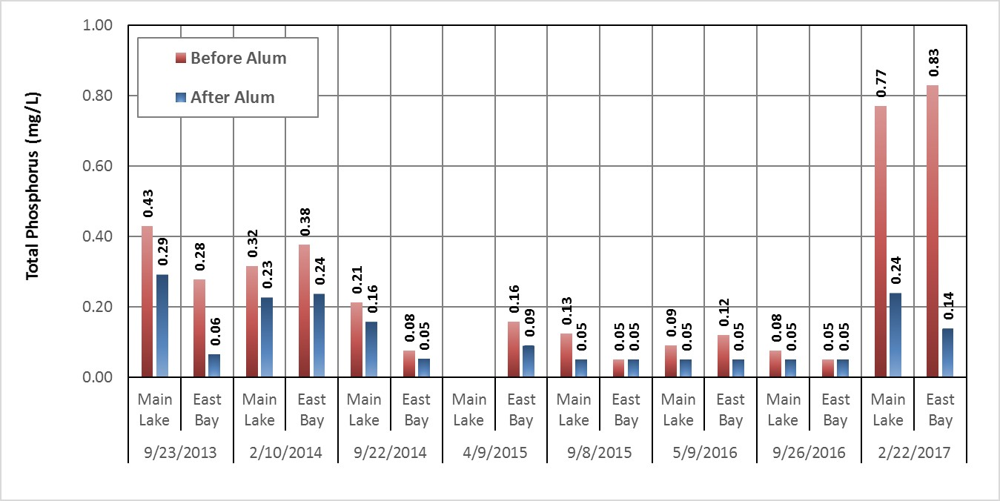
Figure 7-2. Depth Integrated TP Concentration in Canyon Lake Before and After Alum Applications

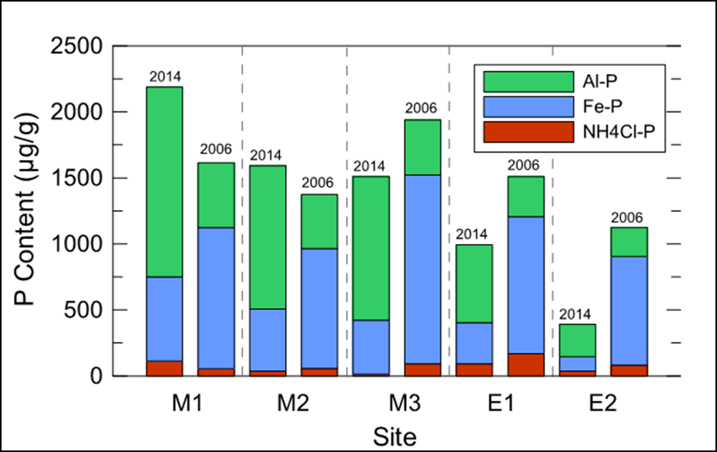
Figure 7-3. Comparison of Canyon Lake Bottom Sediment Samples Showing Changing Partitions of Phosphorus (Figure from Anderson 2015a) (M = Main Body; E = East Bay)

The collective water quality benefits from each of these projects, which serve as the basis for the RAA for Lake Elsinore, are estimated using the Linkage Analysis lake water quality models. Based on this analysis, the expected water quality from ongoing implementation of the existing projects does not equal or exceed estimated water quality expected under a reference condition; therefore, enhancements of existing projects or implementation of supplemental projects may be needed (see Section 7.2.4.2).

LEMP
According to the Environmental Assessment for the LEMP project, the construction of a levee to reduce the surface area of the lake would serve to improve water quality as well as provide sustained recreation opportunities (Engineering-Science 1984, see Table 2-6). A managed lake condition was created when the levee was constructed. The levee is intended to provide better protection of the recreational and aquatic life beneficial uses than would otherwise occur under natural reference conditions.
The location of the levee within Lake Elsinore constrains the relationship between volume and surface area when the lake elevation exceeds ~1240’, and maintains the same hypsography as the historical lake basin at an elevation below 1240’ (see Figure 5-2). As a result, the levee provides only limited benefit during periods of extended drought when water levels drop below 1240’ (Figure 7-4).
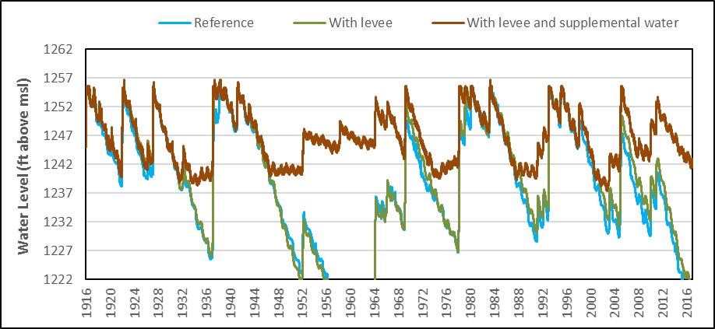
Figure 7-4. Lake Elsinore DYRESM-CAEDYM Model Results for Lake Levels Given 1916-2016 Hydrology, for Conditions with and without the Presence of Levee, and with Additions of Supplemental Water

Addition of Supplemental Water
While the implementation of LEMP was expected to stabilize lake water levels and improve water quality, variations in the lake level and water quality can still be substantial in Lake Elsinore. This is partly due to the location of the levee (described above), climate patterns, but also as a result of runoff retention within Canyon Lake. The construction of Railroad Canyon Reservoir (completed in 1929) had the potential to significantly impact downstream Lake Elsinore, especially given that 90 percent of Lake Elsinore’s drainage area is upstream of Canyon Lake. This was the subject of the Tilley Agreement in 1927 and Fill and Operate Agreement in 1991. These agreements were superseded by the 2003 agreement between the City of Lake Elsinore and EVMWD, which requires EVMWD to maintain water levels in Lake Elsinore at 1240’ in order to divert water from Canyon Lake for municipal drinking water supply. Water is diverted from Canyon Lake rather than Lake Elsinore to assure the quality of water required to meet the MUN beneficial use is met. If the water were allowed to flow downstream to Lake Elsinore and commingle with the high TDS water in Lake Elsinore, it would be too salty (often > 2,000 mg/L TDS) to support the MUN use.
Since 2002, EVMWD has provided supplemental makeup water to maintain lake levels in Lake Elsinore. Sources of supplemental water include EVMWD’s highly treated reclaimed water (~95 percent of total supplemental water) and production from non-potable wells on islands in the lake (~5 percent of total supplemental water) (see Table 4-9).
The lake model assumes reclaimed water will be discharged at 7.5 MGD on all days (1916-2016) when the lake levels dropped below 1240’. This represents the currently available capacity of EVMWD’s treatment plant and the water level conditions at which the local stakeholders have agreed recycled water can be added to Lake Elsinore. Over the 100-year linkage analysis simulation period (1916-2016), the average annual volume of recycled water added to Lake Elsinore under these existing constraints amounted to ~4,500 AFY, with up to ~10,000 AFY in periods of extended drought (such as 2016). During the most recent dry period prior to the winter of 2016-2017, modeling analyses indicate that Lake Elsinore would have been completely dry for more than two years (2015-2016) without the collective hydrologic control achieved from implementation of LEMP and supplemental water additions (Figure 7-4). As such, the managed lake condition including both LEMP and supplemental water addition clearly provided better protection of recreational uses than would be realized in a reference condition (Fortnight: The Magazine of California 1954). Moreover, other public health issues associated with periods of lakebed desiccation, such as severe gnat infestations and dust, were effectively prevented by these existing controls.
While the addition of EVMWD supplemental water to the Lake supports the recreation beneficial uses of the lake, reclaimed water represents an additional external source of nutrient loads in excess of reference conditions, despite the WWTP achieving relatively low effluent nutrient concentration. Thus, there is a potential for increased eutrophication relative to the reference watershed condition. The linkage analysis was used to evaluate the balance of increased nutrient loads against the benefits of increased water volume in Lake Elsinore, including reducing wind driven sediment resuspension, facilitating aquatic vegetation on shorelines, and diluting TDS under most conditions. Figure 7-5 shows model results for TDS under reference and managed conditions (with 100 years of implementing existing controls) as time series histories over the simulation period. Under most circumstances, the addition of recycled water with a TDS of 700 mg/L serves to dilute ambient TDS in the lake (Figure 7-5) (Note: the water quality objective is 2,000 mg/L TDS, about the same as the median TDS concentration observed under the reference condition).
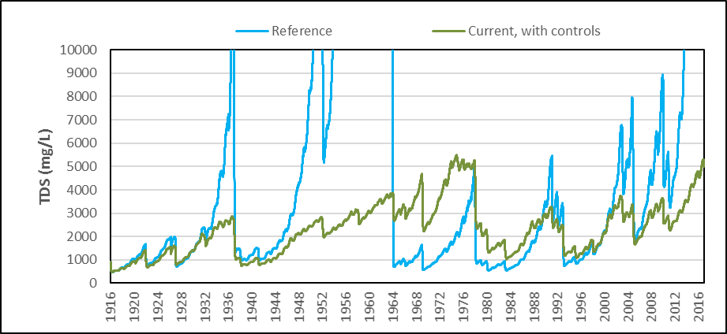
Figure 7-5. Lake Elsinore DYRESM-CAEDYM Model Results for TDS Concentration Given 1916-2016 Hydrology, for Reference Conditions and with the Levee and Additions of Supplemental Water

One exception to the model findings occurs during the period beginning in 1964 - immediately following lakebed desiccation in the early 1960s. If the lake is allowed to dry out, TDS is mineralized in lake bottom sediments and can even be exported from the lake basin as wind-blown dust. When runoff again begins to refill the lake, a TDS lower than reclaimed water is observed, as occurred in 1964. This historical process of drying and refilling provides a natural reset of ambient TDS in Lake Elsinore. Because reclaimed water is now used to manage lake levels to prevent desiccation and support recreational uses, this managed lake condition is expected to yield higher TDS, which can result in less effective zooplankton population for grazing upon algae.
The development of this revised TMDL is based on a common desire of all watershed stakeholders to support recreational uses applicable to Lake Elsinore by maintaining minimum water levels in Lake Elsinore and preventing any future lakebed desiccation events from occurring. Thus, the natural reset process described above cannot be relied upon as a water quality improvement mechanism, nor would it be prudent to allow the lake to dry out as it causes a complete extinction of aquatic life before water quality improvement begins to occur. The numeric target CDFs developed for Lake Elsinore represent periods of lakebed desiccation as having maximum concentrations for chlorophyll-a and ammonia, and zero lake volume above 5 mg/L DO (see Section 3 Numeric Targets).
The 2004 TMDL set WLAs for EVMWD’s reclaimed water discharge. These WLAs provided the basis for effluent limits in the wastewater facility’s NPDES permit. EVMWD’s permit allows for these limitations to be met directly at the point of discharge and/or indirectly through offsets of excess internal nutrient loads by reducing the flux of nutrients from the lake bottom with the construction and operation of LEAMS.

LEAMS
LEAMS was constructed in 2007 as a joint project developed by LESJWA and co-sponsored by EVMWD, the City of Lake Elsinore and Riverside County. LEAMS relies on a combination of slow-turning propellers submerged in the lake and shoreline compressors that disperse air from pipelines anchored to the bottom of the lake to circulate water in Lake Elsinore (Figure 7-6).
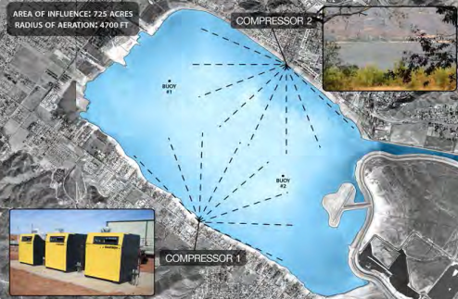
Figure 7-6. Diagram of the Lake Elsinore Aeration and Mixing System (LEAMS)
Water near the bottom of the lake is low in DO. LEAMS is designed to push this bottom water toward the surface where it will be re-aerated, naturally by wind and wave action. Higher DO levels are essential to support fish and other aquatic organisms living in the lake. Stirring the lake to increase DO concentrations also helps improve water quality. Higher DO concentrations help convert ammonia and nitrate to nitrogen gas. Higher DO concentrations also help prevent chemical reduction of iron that releases bound phosphorus to a soluble form that may be released to the water column by diffusive exchange.
EVMWD has submitted required technical analyses demonstrating the achievement of required offsets with LEAMS operation (Horne 2015). Estimated nutrient offset credits from LEAMS operation based on these analyses amount to 3.5 kg TP and 22 kg TN reduced per hour of LEAMS operation. This reduction was corroborated by the DYRESM-CAEDYM model used to complete a RAA to demonstrate water quality benefits achieved from deployment of existing controls including LEAMS (see Section 7.2.4.2 below).

Fishery Management
Physical resuspension is an important source of nutrients in Lake Elsinore as a result of its shallow depth and carp population. Benthivorous fish such as carp resuspend lake bottom sediments in their foraging behavior, a process referred to as bioturbation. Resuspended sediments can cause releases of bioavailable nutrients to the water column. Bioturbation rates in Lake Elsinore are estimated to account for a lake-wide average of approximately 2 mg/m²/day TP and 5 mg/m²/day TN (see Section 4.3). Reductions in carp populations are expected to provide corresponding reductions in TP. For example, a reduction in the carp population to less than 125 fish/ac could reduce bioturbation TP loading rates by 1.3 mg/m²/day TP and 3 mg/m²/day TN (Anderson 2006).
In 2002, LESJWA and the City of Lake Elsinore initiated a multi-year demonstration project to reduce the carp population in Lake Elsinore. From 2002 to 2008, a total of 1.3 million pounds of carp was removed from the lake and by the end of 2008, the estimated carp population was 138 fish per acre (City of Lake Elsinore 2008). Continued management of the carp population in Lake Elsinore will occur as needed.

7.2.4 Estimated Water Quality Benefits

7.2.4.1 Canyon Lake
The RAA for Canyon Lake focuses on reduction of phosphorus within each lake segment to offset additional nutrient loads from external sources. Current surface spreading of alum twice per year in Canyon Lake is sufficient to sequester all excess (above reference condition) phosphorus loading lake-wide, but may require adjustments to dosages between Main Lake and East Bay (Table 7-7). Alum additions may continue in upcoming implementation phases if this approach is included in updates to the CNRP and AgNMP.
The use of alum within the lake segments to offset excess phosphorus is designed to limit cause phosphorus limitation of algae growth (i.e. a single nutrient control strategy). The role nitrogen may play in algae growth is neglected; therefore, the Linkage Analysis models were used to evaluate in-lake water quality response from current alum applications in Canyon Lake. As of this draft section submittal, simulations of alum addition with the ELCOM-CADYM model are underway. Results are not yet completed.
Table 7-7. Current Estimates of Benefits Obtained from Alum Additions to Canyon Lake
Site | TP (kg/yr)
 | Main Lake | East Bay
Current External Load Retained (with existing watershed BMPs) | 516 | 2,548
Allowable Load | 419 | 1,110
Load Reduction Required | 97 | 1,437
Estimated Nutrient Reduction from Alum Additions | 386 | 1,091
Unmet Load Reductions | -289 | 346
¹ There is an area in the lake where intermixing between the Main Lake and East Bay occurs; therefore, the overall unmet load reduction may be close to zero.

7.2.4.2 Lake Elsinore
The RAA for Lake Elsinore involves a simulation of water quality response targets over a 100-year hydrologic period (1916-2016) for the managed lake condition (with existing controls). Existing controls were incorporated into the managed lake condition simulation over the entire simulation period, even though controls were only implemented over the past 20 years. Thus, the 100-year simulation results should not be compared to measured data, but rather serve to estimate the water quality response in the future if hydrology similar to the 1916-2016 period were to occur going forward. Results are compared with the numeric targets, which are based on model results for a reference watershed condition (pre-development era) over the same 100-year hydrologic period. The impact of urban and agricultural development in the watershed is also evaluated for a condition with no water controls to quantify progress made to offset increased external nutrient loads. Parameters are adjusted to represent three linkage analysis scenarios as described below and summarized in Table 7-8:
- Scenario 1: This scenario represents the reference watershed condition and the results were used to develop the numeric targets reported in Section 3. Nutrient concentrations were reduced to reference concentrations for the San Jacinto River watershed (see Section 3.2.2) and it was assumed that no in-lake controls exist.
- Scenario 2: This scenario relies on the existing concentrations of nutrients in watershed runoff inflows with no in-lake controls (see Table 7-2 above). Results portray water quality conditions that may have occurred without the implementation of multiple in-lake controls.
- Scenario 3: This scenario relies on (a) existing concentrations of nutrients in watershed runoff inflows (see Table 7-2 above); and (b) includes the implementation of existing in-lake water quality controls. The results over the past ten years since all in-lake controls have been implemented most closely represent actual conditions. The simulation, which was run for 100 years of hydrology (1916-2016), provides an estimate of the long-term water quality condition that may be achieved with continued operation of existing controls. The Linkage Analysis model takes into account in-lake controls as follows:
  - Watershed BMPs – The benefits from the BMPs are captured in recent data used for assumed inflow TP and TN concentrations. This approach also accounts for any benefits from nutrient control within Canyon Lake.
  - LEMP – Linkage analysis employs the revised lake hypsography.
  - Supplemental Water – Linkage analysis includes additions of supplemental water at 7.5 MGD on days when the lake level drops below 1240’. Over the 100-year simulation period an average annual addition of supplemental water amounts to ~3,500 AFY. The assumed quality of supplemental water for relevant constituents includes: 700 mg/L TDS, 0.5 mg/L TP, and 3.0 mg/L TN.
  - LEAMS – Linkage analysis simulates the influence of increased DO (or reduced anoxia) on sediment nutrient flux near the lake bottom achieved from operation of LEAMS. DYRESM-CAEDYM variables that control hydraulic mixing energy are increased to account for LEAMS and cause an increased DO.
Table 7-8. Scenarios Evaluated with Linkage Analysis to Support Lake Elsinore RAA
Parameter | Scenario 1: Reference Conditions | Scenario 2: Current Development; No Water Quality Controls | Scenario 3: Current Development; With Existing Water Quality Controls
Lake Elsinore Spill Elevation (feet mean sea level) | 1255 | 1255 | 1255
Hypsography | Without levee | Without levee | With levee
Inflow TP (mg/L) in Runoff | 0.32 | 0.51 | 0.51
Inflow TN (mg/L) in Runoff | 0.92 | 1.89 | 1.89
Internal TP Flux (mg/m²/day) | 5.4 | 9.0 | 7.7
Internal TN Flux (mg/m²/day) | 37 | 75 | 72
EVMWD discharge | None | None | Reclaimed water¹
Runoff Flow | USGS gauge + local runoff estimate (1916-2016)
¹Reclaimed water addition assumed at 7.5 mgd with TDS 700 mg/L, TP 0.5 mg/L, TN 3.0 mg/L

A simplifying assumption made for all three scenarios is that hydrologic inflows to Lake Elsinore are functionally equivalent. This assumption neglects the expectation of increased watershed runoff as a result of urban development in the watershed; however, it was determined that any such runoff would be minor relative to the impact to Lake Elsinore inflows from the construction of Railroad Canyon Dam. Railroad Canyon Dam reduces watershed runoff inflow to Lake Elsinore by capture and use of stored water by EVMWD. Conversely, long term sedimentation in Canyon Lake may give rise to an increase in overflows regardless of the upstream watershed condition. Recognizing the value of increased water in Lake Elsinore, no estimate of hydrologic change as a result of watershed development is included in the TMDL revision. While not directly addressed in the 2004 TMDL Staff Report, this assumption is consistent with the modeling conducted for the original TMDL (Santa Ana Water Board 2004).
CDF plots of daily modeling results for each of the three linkage analysis scenarios show that the collective implementation of existing watershed and in-lake BMPs in Lake Elsinore yield water quality conditions for response targets (chlorophyll-a and DO) that are approaching the range of conditions estimated for a reference watershed during most years (i.e., the numeric targets) and providing much better water quality (lower chlorophyll-a and greater lake volume with DO over 5 mg/L) during periods of extended drought (Figures 7-7 and 7-8). At the time of this TMDL revision (beginning in 2015), modeling results show that the lakebed would currently be dry under a reference condition. Accordingly, implementation of existing controls has yielded better than reference condition support for beneficial uses. It is important for existing projects to continue to operate and for their effectiveness to be evaluated against reference conditions over varying hydrologic periods. Ultimately, monitoring data will demonstrate whether sufficient progress toward numeric targets is achieved or if supplemental projects will be necessary in Lake Elsinore.
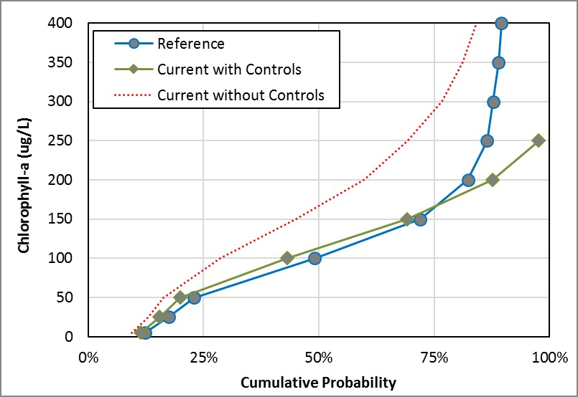
Figure 7-7. CDF Plots of Chlorophyll-a Concentration in Top 1-m of Lake Elsinore for Reference Condition and Current Conditions with and without Existing In-lake Water Quality Controls

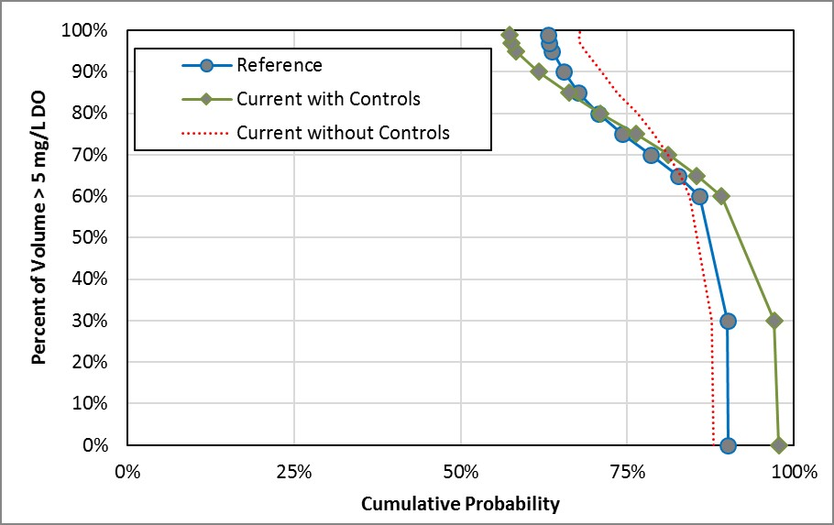
Figure 7-8. CDF Plots of Lake Elsinore Volume with DO > 5 mg/L for Reference Condition and Current Conditions with and without Existing In-lake Water Quality Controls

The RAA results also provide an estimate of reduced internal nutrient loads that are attributable to potential long-term implementation of existing water quality controls (Table 7-9). These nutrient offsets are not solely responsible for in-lake water quality improvements, but rather work in concert with hydrologic controls to provide reductions in algae growth (see Figure 7-7).
Table 7-9. Estimated Reduction of Internal Loads Attributable to Implementation of In-Lake Water Quality Controls
Average Internal Load | TP | TN
Scenario 2: Current without Controls (kg/yr) | 24,442 | 197,605
Scenario 3: Current with Controls (kg/yr) | 17,880 | 79,570
Offset with Current Controls: Scenario 2 – Scenario 3 (kg/yr) | 6,562 | 118,035
Offset with Current Controls (% Reduction) | 27% | 60%

7.3 Supplemental Project Concepts
As part of implementation of the revised TMDLs, the responsible entities with WLAs and LAs will evaluate the need for implementation of supplemental projects to provide additional water quality improvements. At this time, potential supplemental projects could include:

- Enhanced treatment of reclaimed water prior to addition
- Alum additions to wet weather inflows
- Treatment wetlands
- Oxygenation
- Mystic Lake drawdown
- Dredging
- Indirect potable reuse
- Artificial circulation
- Fishery management
- Vegetation management
- Ultrasonic algae control
- Algaecide application
- Physical harvesting

For each of the above supplemental project concepts, Table 7-10 provides a summary of the potential water quality benefits that may be obtained and other considerations associated with implementation. Section 7.4 provides a timeline for consideration of supplemental projects during implementation. The implementation program does not specify which of the listed supplemental projects will be implemented only that these are projects for further consideration. Selection of supplemental projects is an early task in the implementation schedule.

Table 7-10. Potential Supplemental Projects for Consideration During the Phase 2 Program of Implementation
Project | Action | Source | Waterbody | Cost | Description | Water Quality Benefits | Potential Constraints & Limitations
Mystic Lake Drawdown | Hydrologic flushing | Internal | Lake Elsinore, Canyon Lake (Main/ East Bay) | $$$ | Mystic Lake is a sump that captures all runoff from the upper SJR watershed via a breach in the levee on the north side of the river near Bridge Street. Most runoff that does reach Mystic Lake is retained and subsequently lost via evaporation. The most recent overflow to Canyon Lake occurred in 1998. Few data exist on the flow that reaches Mystic Lake, but the watershed model estimates ~3000 AFY, with many years having zero volume inflow and many years with over 10,000 AFY. While intermittent, this water may have a significant value for EVMWD water supply (at Canyon Lake) and for water quality in both lakes (providing both flushing and dilution). A potential project would involve pumping and conveying the stored runoff out of Mystic Lake (bottom elevation 1408' to the overflow channel leading to the lower SJR (invert elevation 1423'). | - Flushing of nutrients and phytoplankton out of Canyon Lake  - Increasing water levels and dilution of TDS in Lake Elsinore | - Intermittent source of water, further reductions of inflows could occur with increased upstream capture  - Impacts to waterfowl and other wildlife  - Determination of appropriate increased diversions for EVMWD's treatment plant  - Subsidence could impact facilities over time
EMWD Effluent Treatment | Phosphorus removal | External | Lake Elsinore | $ | While EVWMD already treats wastewater to a very nutrient concentration, further polishing with additional alum additions could provide even lower concentrations of phosphorus in reclaimed water additions | Reduction of TP in water column | - Less efficient phosphorus removal when treating water with low initial concentrations  - Ensure chemical additions do not conflict with other WWTP processes
Alum Addition to Wet Weather Inflows | Phosphorus removal | Internal | Lake Elsinore, Canyon Lake (Main/East Bay) | $ | An alternative delivery method for alum additions could involve a small chemical feed storage and deliver system at the two inflows to Canyon Lake. This would treat bioavailable phosphorus immediately as it arrives in the lake and provide a better flocculation with lower pH of wet weather runoff. | Reduction of TP in water column | - Requires on-site chemical storage of low pH material  - Outdoor chemical feed system may be susceptible to damage by high flows, wind or vandalism
Increased Recycled Water Additions | Hydrologic flushing/ dilution | Internal | Lake Elsinore | $$ | EVMWD currently discharges up to 7.5 of its 8 mgd capacity to Lake Elsinore. Phase 1 of the WWTP expansion will allow for discharge of up to 9.0 mgd to Lake Elsinore by 2020, a rate estimated to provide sufficient capacity to maintain at water level of 1240' over the long term. Increased recycled water addition will dilute TDS during periods of drought, and increase habitat for submerged vegetation and fish. | Reduction in TDS, aquatic habitat, indirect controls on nutrient cycling and algae | Agreement to ensure up to 9.0 mgd will be discharged to Lake Elsinore in perpetuity
Enhanced Watershed Sediment and Debris Capture | Phosphorus and nitrogen reduction | External | Lake Elsinore, Canyon Lake - Main Lake and East Bay | $$ | The State Water Board established a statewide trash management policy in 2015 applicable to all inland surface waters (State Water Board 2015). Depending upon land use, the provisions in the statewide policy require deployment of full capture (> 5 mm diameter) systems or allow for a combination of controls to achieve equivalent capture. Implementation is anticipated to occur over a 10-year period by MS4 permittees within each lake’s watershed following the policy’s effective date. In addition to reduced trash, it is expected that policy implementation will result in other water quality benefits. | Reduction of TP and TN in water column | None; program required for implementation through MS4 Program
Treatment Wetlands | Phosphorus & nitrogen reduction | Internal | Lake Elsinore | $$$ | The Back Bay wetlands were created as part of the LEMP project to provide habitat areas. Use of the wetlands for water quality treatment was not the objective of the current facility and therefore there is negligible nutrient removal achieved. A project could be developed to modify the wetlands to provide increased residence time and greater nutrient reduction. | Reduction of TP and TN in water column | - Nutrient reduction in wetland system is uncertain  - Longer residence time needed for nutrient removal may require larger wetland footprint
Oxygenation | DO control, phosphorus & nitrogen reduction | Internal | Canyon Lake (Main) | $$ | Oxygenation involves the direct addition of oxygen to the lake bottom waters in Canyon Lake Main Lake during periods of thermal stratification. The oxygen would reduce anoxic conditions in the lake bottom and thereby limit the internal loading of nutrient to the water column | Reduction of TP and TN in water column | - Low DO in hypolimnion of Canyon Lake occurs in reference condition  - Requires large scale on-site oxygen storage
Dredging | Phosphorus & nitrogen reduction | Internal | Canyon Lake (Main/East Bay) | $$$$ | Dredging involves the physical removal of lake bottom sediments. This is a very effective way to reduce the pool of mobile nutrients within the lake bottom. | Reduction of TP and TN in water column | - Dredging is very costly  - Disposal of sediment may require hauling
Indirect Potable Reuse | Hydrologic flushing | Internal | Canyon Lake (Main/East Bay) | $$$$ | EVMWD may consider using Canyon Lake as an environmental buffer to allow for potable reuse of advanced treated reclaimed water. Advanced Wastewater Treatment (AWT) water would be discharged at the upstream end of the lake to maximize residence time prior to reaching the drinking water treatment plant intake. AWT water would serve to dilute ambient water in the lake as well as create additional flushing of water when overflows are not occurring. | Reduction of TP and TN in water column; flushing of nutrients and phytoplankton out of Canyon Lake | - Water quality in the lake may limit the amount of reclaimed water that can be diverted for potable supply.  - Operation of the system during the wet season may be less reliable given water quality and capacity limitations.
Vegetation Management | Algae control | Internal | Lake Elsinore, Canyon Lake (Main/East Bay) | $$ | Establishment of submerged aquatic vegetation that will take up nutrients and release oxygen to the water column. Macrophytes can compete for limited nutrients and light with algae thereby providing another control on algae growth. | Reduction of TP and TN in water column, control of algae growth | - Macrophytes may not get established.  - Water level fluctuations can kill vegetation by either desiccation or drowning.
Ultrasonic Algae Control | Algae control | Internal | Canyon Lake (East Bay) | $ | Devices can be deployed that will kill algae within a 50-foot radius by sonication | Control of algae growth | - Sonication is effective over a small area and may require too many devices to impact larger zones.  - Impact to other aquatic species could become an important consideration
Algaecide | Algae control | Internal | Canyon Lake (Main/East Bay) | $ | Algaecides may be effective in controlling algae blooms as they begin to occur | Control of algae growth | - Repeated use of some algaecides can cause elevated levels of toxins in the lake bottom  - Nutrients are not addressed and therefore new algae blooms may arise shortly after an algaecide treatment
Physical Harvesting | Algae control | Internal | Lake Elsinore, Canyon Lake (Main/East Bay) | $$ | Skimmers and other tools can be used to physically remove algae from the surface of the lake | Control of algae growth | - Labor intensive  - Nutrients are not addressed and therefore new algae blooms may arise shortly after physical removal
LE Advance Pumped Storage (LEAPS) | Hydrologic flushing, DO control | Internal | Lake Elsinore | $$$ | Construction of a 200' tall dam and new 50 to 100-acre concrete lined reservoir with a spill elevation of ~2,800' in the Cleveland National Forest southwest of Lake Elsinore. On average, 5,000 AF of water would be pumped from Lake Elsinore in the evening during periods of low energy demand. Return of the water would generate hydroelectric power in turbines between the new 'upper' reservoir and Lake Elsinore, the 'lower' reservoir. | Control of algae growth, reaeration, potential to reduce P with additional treatment | Potentially numerous regulatory challenges to obtain approval

7.4 Program of Implementation
The program of implementation under the revised nutrient TMDLs considers the existing water quality management strategies already being implemented to improve water quality in Lake Elsinore and Canyon Lake, as follows:
- Lake Elsinore - For more than 30 years this lake has been managed to stabilize the lake level with a targeted surface elevation of 1240’. This management strategy is contrary to the natural condition, which results in a periodically dry lake. Managing the lake to keep it “wet” changes the water quality dynamics of the lake not only for nutrients but other constituents such as salinity and DO. Regardless, a wet-lake management strategy ensures support of existing recreational beneficial uses. The program of implementation under the revised TMDLs will continue this lake management approach.
- Canyon Lake – Efforts to improve water quality in this reservoir are focused on managing nutrients within the watershed consistent with the nutrient loads expected from a reference watershed. This approach coupled with the implementation of in-lake water quality controls through the application of alum is expected to result in a lake that is in compliance with the TMDL and attainment of applicable water quality objectives. This approach will continue under the program of implementation.

The above management strategies will be implemented under an overall phased implementation framework. The following sections describe this framework.

7.4.1 Implementation Framework
TMDL implementation in Lake Elsinore and Canyon Lake has been occurring since 2005 after the effective date of the original TMDLs. Previous implementation work coupled with future implementation activities encompasses the implementation framework as described below.

7.4.1.1 Phase 1 (Current Phase)
Since that the effective date of the 2004-adopted TMDLs, the entities responsible for compliance with the TMDLs have implemented numerous activities to meet the applicable WLAs and LAs and completed technical studies to better understand the water quality dynamics of each of these lakes. This approximately 15-year period of implementation, which represents Phase 1 of the overall implementation framework (Table 7-11), has resulted in a significantly increased understanding of watershed reference condition, lake dynamics during wet and dry periods and what is attainable with regards to the existing causal and response targets established in the 2004 TMDL. Given the findings from Phase 1 and the analyses completed to support the revision of the original TMDLs, future implementation will include up to two phases (see Table 7-11).

7.4.1.2 Phase 2
Section 2 (Problem Statement) described the unique hydrologic variability of Lake Elsinore and highlighted the existence of multi-decadal climatic cycles. For example, based on USGS flow gauge data, it would take a period of 40-years after meeting the TMDL to obtain a repeatable (within 20 percent) average runoff inflow to Lake Elsinore from Canyon Lake overflows (see Figure 6-4). Paleolimnology records suggest even longer climate cycles exist (Kirby et al. 2005). Moreover, the impacts of global climate change may exacerbate patterns of hydrologic variability in the future by increasing the severity of extended droughts (e.g., see California Natural Resources Agency 2014).
Given the longevity of climatic cycles and the potential impacts from climate change, compliance with the TMDL numeric targets and attainment with water quality objectives may not be demonstrated for multiple decades. However, periodic water quality assessments can be conducted, which not only provide the means to measure progress towards attainment of the water quality objectives, but also provide the opportunity to modify implementation actions over time through the adaptive implementation process.
The long timeframe associated with this multi-decadal assessment process is reflected in the Phase 2 program of implementation. Phase 2, which begins upon the effective date of the revised nutrient TMDLs, is anticipated to have a duration of 15-20 years and will include activities that range from continued implementation of existing nutrient controls to completion of supplemental projects, where deemed necessary. The length of this phase allows time to:
- Update existing permits and programs (up to 2-3 years);
- Conceptualize, design, permit, and construct new projects (minimum of 5-7 years); and
- Evaluate the effectiveness of updated and newly implemented projects (likely to require 10 or more years to cover a full meteorological cycle, i.e., dry and wet cycles).
The time frame for Phase 2 implementation also allows time for the potential impacts from continued changes in the watershed and lakes to occur, resulting from:
- Ongoing conversion of agricultural lands to an urban landscape;
- Expected increase in addition of supplemental reclaimed water to Lake Elsinore; and
- Continued reduction of bioavailable nutrients in the lake sediments.
Table 7-11. Phased Implementation Framework for Lake Elsinore and Canyon Lake TMDLs
Phase | Time Period | Completed or Anticipated Key Activities | Existing or Anticipated Outcomes
Phase 1 | Effective date of original TMDLs to effective date of revised TMDLs (2005 - ~2019) | - LECL Task Force Management  - Alum applications  - LEAMS implementation  - Fishery management  - Watershed BMPs (CNRP, AgNMP)  - Supplemental water additions  - Special studies to support TMDL revisions  - Monitoring and reporting activities | - Implementation of watershed-based and in-lake BMPs to reduce nutrient loads to the lakes and mitigate nutrient impacts  - Development of new data to support revision of nutrient TMDLs
Phase 2 | 15-20 year period after effective date of revised TMDLs | - Revised permits and management plans  - Continued/enhanced implementation of existing water quality control programs  - Supplemental project implementation, as needed  - Additional research/studies, as needed  - Annual monitoring and reporting  - Periodic assessment to evaluate progress towards compliance with TMDLs and attainment of water quality objectives | - Compliance with TMDL numeric targets and attainment of water quality objectives  - Evaluation of the need for Phase 3 implementation if compliance with TMDL targets or water quality objectives not yet attained
Phase 3  (as needed) | After completion of Phase 2 to no later than 40 years after revised TMDLs effective date | - Consider additional projects  - Consider revision of beneficial uses and/or water quality objectives to better define highest attainable use(s)  - Revise TMDLs based on latest data/information | - Compliance with TMDL numeric targets and attainment of water quality objectives

7.4.1.3 Phase 3
The TMDLs will be re-evaluated after about 20 years (end of Phase 2, or approximately 2040). This next phase will be required only if after implementation of Phase 2 activities it is determined that compliance with TMDL nutrient targets and attainment of water quality objectives may not be achieved under completed and ongoing water quality control activities. If Phase 3 is deemed necessary, not only would additional water quality projects be evaluated for implementation, but modification to applicable beneficial uses and water quality objectives also would be considered, as discussed below.

7.4.2 Phase 2 Implementation
The revised nutrient TMDLs are subject to approval by the Santa Ana Water Board, State Water Board, California Office of Administrative Law and the federal EPA. The revised TMDLs become effective upon EPA approval. Phase 2 implementation begins upon this effective date. Table 7-12 provides a summary of the activities expected to be completed during Phase 2 and associated milestones for completion of these activities based on the effective date of the TMDLs. The following subsections provide additional information regarding each of these planned activities.

7.4.2.1 Stakeholder Coordination
The LECL Task Force, administered by LESJWA, has been instrumental in the ongoing implementation of the existing nutrient TMDLs. This group has collaboratively implemented the research and analysis needed to establish the revised TMDLs for Lake Elsinore and Canyon Lake. It is recommended that the LECL Task Force continue to meet at least quarterly and continue its efforts to implement the types of studies and monitoring programs necessary to make continued progress in improving water quality in these lakes and complying with the TMDL numeric targets.

7.4.2.2 Revision to Existing Waste Discharge Requirements and Other Regulatory Actions
The Santa Ana Water Board will revise, where needed, existing regulatory decisions (e.g., Waste Discharge Requirements [WDRs], CWAD, 404 permits, 401 certifications, effluents limits) in the San Jacinto River watershed to support implementation of the revised TMDLs. In addition, the Santa Ana Water Board will use its regulatory authorities to recommend actions by other agencies or entities, where deemed appropriate to support TMDL compliance. Santa Water Board Actions will include:

Revision to Existing Permits
The Santa Ana Water Board will review and revise, as necessary, the following existing permits to incorporate revised WLAs, LAs and monitoring program requirements:
- National Pollutant Discharge Elimination System (NPDES) Permit and Waste Discharge Requirements for the Riverside County Flood Control and Water Conservation District, the County of Riverside and the Incorporated Cities of Riverside County within the Santa Ana Region, Areawide Urban Runoff, NPDES No. CAS 618033 (Order No. R8-2010-0033) (Santa Ana Water Board 2010).

Table 7-12. Summary of Implementation Activities
Implementation Element | Activity | Responsible Entity (ies) | Complete by
Stakeholder Coordination | LECL Task Force collaborate at least quarterly on TMDL implementation activities | All entities with a WLA or LA and Santa Ana Water Board | Throughout Phase 2
Revision to Existing Permits and Other Regulatory Actions | Riverside County MS4 Permit | Santa Ana Water Board | Initiate revisions where necessary within 90 days of TMDL effective date
 | March Air Reserve Base MS4 Permit
 | Conditional Waiver for Agricultural Operations
 | EVMWD WDR
 | Dairy General Order
 | Caltrans MS4 Permit | State Water Board
 | USFS Nutrient Management Plans | Santa Ana Water Board, State Water Board, and EPA | Revised Management Plans within 3 years of TMDL effective date
Implementation and/or Revision of Existing Water Quality Controls | Canyon Lake Alum Project | Entities with a WLA or LA applicable to Canyon Lake | As needed application
 | LEAMS | Entities with a WLA or LA applicable to Lake Elsinore | Continued implementation as per LEAMS operational agreements
 | Fishery Management | Entities with a WLA or LA applicable to Lake Elsinore | As needed
 | Comprehensive Nutrient Reduction Plan | MS4 Permittees | Revised CNRP within 2 years of reauthorization of MS4 permit
 | Agricultural Nutrient Management Plan | Agricultural Operators | Revised AgNMP within 2 years of TMDL effective date
 | Supplemental Reclaimed Water | EVMWD | Maintain minimum discharge of supplemental water
Evaluation of Technical Basis of TMDL Assumptions | Nutrient Loads from Reference Watershed | All entities with a WLA or LA | Complete study within 3 years of TMDL effective date
 | Other Special Studies | All entities with a WLA or LA | As needed, milestones determined by specific study
Revised Monitoring Program | Revised Monitoring and Reporting Program | All entities with a WLA or LA | Submitted within 90 days of TMDL effective date; implemented within 90 days of Santa Ana Water Board approval
 | Annual Water Quality Reports | All entities with a WLA or LA | By August 15 each year
 | Evaluate Status of TMDL Compliance | All entities with a WLA or LA | By August 15 of every fifth year after TMDL effective date
Supplemental Projects | Determine need for and select Supplemental Projects; establish workplan and schedule for implementation | All entities with a WLA or LA | Within 4 years of effective date of TMDLs
Adaptive Management Analysis | Evaluation of need for Phase 3 | All entities with a WLA or LA | No later than 20 years after TMDL effective date
Demonstrate Attainment with Water Quality Objectives | Adaptive Management | All entities with a WLA or LA | Focus of TMDL implementation in second 20 years; milestones determined based on Phase 3 evaluation above
 | TMDL re-opener (if deemed necessary following completion of special studies) | All entities with a WLA or LA
 | Determine need for revised beneficial uses and/or site-specific objectives for Lake Elsinore; establish workplan and schedule for implementation | All entities with a WLA or LA

- Conditional Waiver of Waste Discharge Requirements for Discharges from Agricultural Operations in the Watersheds of the San Jacinto River and its Tributaries, and Canyon Lake and Lake Elsinore and their Tributaries, collectively, “The San Jacinto River Watershed” Riverside County (Order No. R8-2016-0003, as amended by Order R8-2017-0023) (Santa Ana Water Board 2017).
- Waste Discharge and Water Reclamation Requirements for the Elsinore Valley Municipal Water District, Regional Water Reclamation Facility, Riverside County (Order R8-2013-0017; NPDES No. CA8000027) (Santa Ana Water Board 2013b).
- National Pollutant Discharge Elimination System (NPDES) Permit and Waste Discharge Requirements for United States Air Force, March Air Reserve Base, Storm Water Runoff, Riverside County (Order No. R8-2010-0005, NPDES No. CA 0111007) (Santa Ana Water Board 2015c).
- General Waste Discharge Requirements for Concentrated Animal Feeding Operations (Dairies and Related Facilities) within the Santa Ana Region (Order No. R8-2013-0001; NPDES No. CAG018001) (Santa Ana Water Board 2013c).
- National Pollutant Discharge Elimination System (NPDES) Statewide Storm Water Permit Waste Discharge Requirements (WDRs) for State of California Department of Transportation, California State Water Resources Control Board (Order 2012-0011-DWQ, as amended; NPDES No. CAS000003) (State Water Board 2012).
Within 90 days after the effective date of the revised TMDLs the agencies responsible for each of the permits identified above shall initiate the process, where necessary, to revise the permits or conditional waivers to incorporate findings from the revised TMDLs.

Actions Recommended for Implementation by Other Agencies
The Santa Ana Water Board will work with the U.S. Department of Agriculture/U.S. Forest Service (USFS) on revisions to, or implementation of, the San Bernardino National Forest and the Cleveland National Forest Management Plans to manage the discharge of nutrients from federally-owned lands to reduce nutrient loads. Nutrient loads should be reduced to the maximum extent practicable to the expected nutrient load from the watershed reference condition. In addition, when wildfire occurs, BMPs shall be actively implemented on federally-owned lands to minimize downstream water quality impacts from mobilized nutrients. Required revisions to USFS Management Plans shall be completed within three years of the effective date of the revised TMDLs.

7.4.2.3 Implementation of Existing Water Quality Controls
Since adoption of the original TMDLs the implementation of nutrient management programs through discharge permits, water quality management programs and operation of engineered BMPs have resulted in improved water quality in both Lake Elsinore and Canyon Lake. These projects and programs should continue to be implemented and, where appropriate, updated to incorporate the latest available, relevant information. However, per Section 13360(a) of the California Water Code, the Board cannot specify the method of compliance with a regulatory requirement, including TMDL WLAs or LAs. As such, going forward the entities responsible for TMDL compliance will need to determine the best method, e.g., selection of BMPs or participation in an offset program, to achieve compliance with the requirements of these TMDLs.

Application of Alum
The LECL Task Force selected alum as the most cost effective nutrient control strategy for Canyon Lake, based on the findings of analyses completed using the Canyon Lake model (Anderson 2012a). Application of alum began in September 2013 and has continued semi-annually through 2017. As a result of these treatments, Canyon Lake appears to have shifted to a more phosphorus-limited condition, which was the goal of this water quality management approach. It is recommended that alum addition to Canyon Lake continue as the key in-lake BMP under the Phase 2 TMDL implementation program; however, alum additions will be implemented on an as needed basis. The LECL Task Force will periodically evaluate monitoring program data to determine the need and appropriate application locations and dosage.

Lake Elsinore Aeration and Mixing System (LEAMS)
LEAMS was implemented in Lake Elsinore to improve water quality by improving dissolved oxygen concentrations. It is recommended that LEAMS continue to be operated during Phase 2 as it is expected to continue to remove significant nitrogen from Lake Elsinore. The agreements established to support the operation and use of LEAMS to support TMDL implementation should continue to be revised and/or updated as needed by the signatories to these agreements.

MS4 Nutrient Management Activities
The CNRP, approved in 2013 to fulfill a requirement in Riverside County’s 2010 MS4 Permit, established a nutrient control program to reduce nutrient loading in dry weather flows and stormwater runoff within areas under MS4 jurisdiction in the Canyon Lake and Lake Elsinore watersheds. The CNRP proposed implementation of an alum addition program to Canyon Lake and continued operation of LEAMS as in situ nutrient control strategies (see above). These proposals have been fully implemented since CNRP adoption. During Phase 2, the CNRP should be updated as needed to identify modifications to nutrient control BMPs implemented as part of the MS4 program implemented within the watershed. Implementation through the MS4 permit should include (a) incorporation of expected water quality benefits from implementation of new requirements to control trash in the MS4 (State Water Board 2015); and (b) new development/redevelopment WQMP tracking to facilitate proper accounting of nutrient load reduction credits.

Agriculture Nutrient Management Plan
The existed AgNMP should be reviewed and, as needed, updated to support implementation of the Phase 2 TMDL implementation program.

Reclaimed Water for Stabilization of Lake Elsinore Lake Level
Existing agreements to add reclaimed water to Lake Elsinore will continue to be implemented during Phase 2. Currently, approximately 7.5 mgd is being discharged to Lake Elsinore. With increased development in the area, this discharge is expected to increase to 9.0 mgd by 2020, which will further stabilize lake levels. For the purposes of the Phase 2 implementation program, this increased discharge of reclaimed water to Lake Elsinore is considered a supplemental project (see Table 7-10).

Fishery Management
It is recommended that the LECL Task Force periodically conduct fish surveys to evaluate carp population levels and determine whether additional fishery management activities are necessary to reduce the potential for bioturbation from excessive carp.

7.4.2.4 Evaluation of Technical Basis of Assumptions in Revised TMDLs
The revised nutrient TMDLs are based on assumptions developed from numerous technical studies completed during Phase 1 or since adoption of the original TMDL in 2004. During Phase 2, it is recommended that stakeholders consider implementation of the following specific studies or implement other special studies where deemed necessary to support implementation.

Reference Watershed Nutrient Loads
To establish nutrient concentrations representative of a reference watershed, the TMDL relies on water quality data from the San Jacinto River at Cranston Guard Station monitoring site (see Section 3.2.2.3). Other grab samples from undeveloped canyon sites in the San Jacinto watershed does support the estimated values for total phosphorus and total nitrogen from undeveloped watersheds represented by the Cranston Guard Station. To establish a larger dataset to validate the representation of reference nutrient concentrations in the San Jacinto River watershed, it is recommended that the responsible entities research options for selection of additional watershed reference sites. As part of this research, a special study could be conducted to identify best locations for inclusion in the watershed monitoring program including the original Cranston Guard Station site. Any final selected sites would be incorporated in the San Jacinto River Watershed monitoring program (see Section 7.2.4.5).

Other Special Studies
Stakeholders will implement special studies on an as needed basis to provide supporting data for anticipated technical or regulatory outcomes. These studies may be deemed necessary to verify assumptions in the revised TMDLs or refine understandings of watershed or lake dynamics, e.g., with regards to nutrients, or update lake models. For example, wildfire has been implicated as a potential source of increased nutrients in the watershed. Studies could be developed to further understand the role of wildfire in establishing background or reference nutrient conditions in the watershed. Where a special study is recommended for implementation, a workplan, budget and schedule will be developed for consideration by the LECL Task Force.

7.4.2.5 Develop and Implement Revised Monitoring and Reporting Program
Section 8 of this TMDL Report provides recommendations for revisions to the existing Lake Elsinore and Canyon Lake monitoring and reporting program (MRP) established to implement the existing TMDLs. After the revised TMDLs become effective, the entities responsible for compliance with WLAs or LAs in each lake shall revise the existing MRP, as needed. This revision process shall be completed as follows:
- Revised MRP – Within 90 days of the effective date of the revised TMDLs, a revised state Surface Water Ambient Monitoring Program (SWAMP)-compliant program shall be submitted to the Santa Ana Water Board for approval. The revised MRP shall be implemented within 90 days of Santa Ana Water Board approval.
- Annual Water Quality Report – By August 15 of each year, an Annual Water Quality Report shall be submitted to the Santa Ana Water Board. This report shall summarize the findings from in-lake and watershed monitoring activities for the previous one-year period from July 1 through June 30.
- Effective Assessments - Every fifth year from the TMDL effective date the Annual Water Quality Report shall be expanded to include an analysis of the effectiveness of the TMDL Implementation Program and evaluate progress towards achieving compliance with the WLAs and LAs and attainment with applicable water quality objectives.

7.4.2.6 Implementation of Supplemental Nutrient Management Projects
Table 7-10 in Section 7.3 identifies a range of potential projects that have the potential to provide additional water quality improvements in the watershed. Given the potential need for supplemental projects in either lake, within three years of the effective date of the revised TMDLs, the following evaluations will be completed:
- Entities responsible for compliance with the WLAs and LAs in Lake Elsinore will submit a report that evaluates the need for one or more supplemental projects to further improve water quality in the Lake to meet the requirements of the nutrient TMDL. The report will identify the project(s) proposed for implementation, the expected water quality benefits and provide a workplan and schedule for the completion of the project(s). If no additional projects are deemed necessary to achieve the WLAs or LAs, the report will provide the basis for this finding.
- Entities responsible for compliance with the WLAs and LAs in Canyon Lake will submit a report that evaluates the need for one or more supplemental projects to further improve water quality in the Lake to meet the requirements of the nutrient TMDL. The report will identify the project(s) proposed for implementation, the expected water quality benefits, and provide a workplan and schedule for the completion of the project(s). If no additional projects are deemed necessary to achieve the WLAs or LAs, the report will provide the basis for this finding.
Supplemental projects may include the projects identified in Table 7-10 or other projects identified during the evaluation process.

7.4.2.7 Adaptive Management – Evaluate Need for Phase 3
Towards the end of Phase 2, after all planned projects have been implemented and sufficient time has passed to evaluate their effectiveness, the responsible entities will evaluate the need for a Phase 3. A Phase 3 is only needed if it cannot be demonstrated that compliance with TMDL numeric targets will be achieved even after implementation of all existing water quality control activities. If compliance with the TMDL numeric targets have not yet been achieved, but it is determined that continued implementation of Phase 2 activities will result in compliance, then the Phase 2 efforts will continue until compliance is achieved. If it is determined that existing Phase 2 water quality control efforts will not result in compliance with TMDL numeric targets, then a Phase 3 program will be implemented.

7.4.3 Phase 3 Implementation
A Phase 3 implementation program is only necessary if a finding is made that Phase 2 activities will not result in compliance with TMDL numeric targets for Lake Elsinore, Canyon Lake or both. If Phase 3 is necessary, before potential additional water quality projects are considered for implementation, both the TMDLs and the underlying water quality regulations will be considered for modification. Modification to beneficial uses and/or water quality objectives may be necessary at this time based on what is determined to be the highest attainable use. The following subsections summarize the key elements for consideration under Phase 3. Additional elements may be included based on the state of knowledge at the end of Phase 2.

7.4.3.1 Potential Basis to Revise Beneficial Uses and/or Site-specific Objectives Applicable to Lake Elsinore
The long-term management of Lake Elsinore, as described above, focuses on activities to keep the lake level at or above 1,240’. This management approach will help ensure the REC1 and REC2 beneficial uses are fully supported and will result in lower fluctuations in EC or TDS concentrations in the lake. However, even with these management priorities the lake will continue to experience EC/TDS levels that are not typical of warmwater freshwater ecosystems.
The Basin Plan War Freshwater Habitat (WARM) use is applicable to warmwater ecosystems and per the State Water Board the conductivity of freshwaters typically ranges from 100 to 2,000 µmhos/cm which is approximately equivalent to 64 to 1,280 mg/L TDS (State Water Board 2004; Metcalf and Eddy 1991). Ocean water typically has a conductivity of about 55,000 µmhos/cm or approximately 35,000 mg/L TDS. In between these extremes, waters are typically considered brackish as may be observed in naturally saline lakes or tidally influenced coastal waters. The Basin Plan includes an Estuarine Habitat (EST) beneficial use applicable to these types of ecosystems.
As demonstrated in Section 2.2.2 Lake Elsinore experiences long-term, significant fluctuations in EC/TDS as the lake goes through dry and wet cycles. It is well documented that these cycles occurred under pre-development, natural conditions. Significant variations in salinity have a substantial impact on the biological community of Lake Elsinore and, therefore, the highest attainable aquatic life use. A review of Figure 2-28 shows that since 2003 TDS in the lake has been at or above 1,500 mg/L TDS – above levels consistent with a waterbody classified as a warmwater ecosystem. Instead, the lake more often has salt concentrations typical of estuarine habitats. Given the variation in EC/TDS levels and changing ecosystem condition, i.e., freshwater vs. estuarine, it may be necessary to modify the Lake Elsinore aquatic life use classification in one of the following ways:
- Modify the WARM use designation from “existing or potential” to “intermittent” and define the salinity conditions under which the WARM use applies. Per the Basin Plan, an intermittent use designation may be appropriate where “water conditions do not allow the beneficial use to occur year-round.” In the case of Lake Elsinore, the WARM use could be intermittent for multiple years depending on the length of wet and dry cycles.
- Change the beneficial use from WARM to EST and similarly designate the use as “intermittent” since there are times when the lake will have salinity conditions more representative of a freshwater ecosystem.
In either case, the modification to the aquatic life use for Lake Elsinore would recognize the variability that naturally occurs – regardless of developed or pre-developed conditions. With the appropriate classification established, establishment of appropriate site-specific objectives may be considered. For example, Lake Elsinore currently has a TDS site-specific water quality objective of 2,000 mg/L with a footnote that states, “lake volume and quality highly variable” (note this objective is above the upper limit of what the State Water Board defines as a freshwater ecosystem). Given that the lake often exceeds this objective, a more appropriate site-specific objective could be established that better reflects typically salinity in the lake.
Modification to the Basin Plan’s current beneficial uses or water quality objectives applicable to Lake Elsinore will require significant time and resources and collaboration with the Santa Ana Water Board staff. Therefore, if the entities responsible for compliance with the WLAs or LAs plan to implement a project to modify the Basin Plan, it is recommended that a workplan with a detailed scope of work, schedule and funding plan be developed and approved before work is initiated.

7.4.3.2 Revise Nutrient TMDLs
At the beginning of Phase 3 the nutrient TMDLs should again be evaluated to determine if there is a need for another revision. Revisions may be necessary for the following reasons:
- Throughout the implementation of Phase 2 the findings from the annual surveillance and monitoring program and special studies may provide the basis for further modification of the underlying assumptions of the TMDLs.
- If the beneficial uses and/or water quality objectives are modified, then the TMDLs will have to be revised to reflect the changes in the underlying regulations that provide the basis for the TMDLs.
If a revision to the nutrient TMDLs is warranted, then the responsible entities in collaboration with the Santa Ana Water Board will prepare a workplan with a detailed scope of work, budget and schedule to complete the revisions. If the revisions will be based on changes to the beneficial uses and/or water quality objectives, those regulatory changes should be adopted and formally approved before the TMDL revision process begins.

7.4.3.3 Potential Need for Additional Water Quality Solutions
Phase 3 may include implementation of additional water quality control projects. The specific projects considered for implementation may be developed from the supplemental project list previously evaluated under Phase 2 (see Table 7-10) or may include additional projects. The process and schedule for implementation of any new projects would be determined early in Phase 3.

The Santa Ana Water Board established a moratorium on septic systems in the Quail Valley area in 2006 (Santa Ana Water Board 2006b).
Agreement entered on October 29, 1927, among George H. Tilley and Samantha Tilley, his wife, James Alexander and Anna Alexander, his wife, A.R. Anderson and Clarice Anderson, his wife, South Elsinore Development Company, a corporation, the Mariposa Company, a corporation, D.W. Harvey and F. Mae Harvey, his wife, Clevelin Realty Corporation, a corporation, S.H. Burton and Ellen W. Burton, his wife, Lake-Shore Beach Company, a corporation, Charles H. Rippey, Jr. and A. Marie Rippey, his wife, R.J. Hadsell and Sadie J. Hadsell, his wife, J.L. Cope, South Elsinore Mutual Water Company, a corporation, Alexander Muhlberg and Emilie E. Muhlberg, his wife, and City of Lake Elsinore, a municipal corporation, and Temescal Water Company, a corporation.
Agreement entered by and between the City of Lake Elsinore, Lake Elsinore Redevelopment Agency and the Elsinore Valley Municipal Water District on December 19, 1991.
Lake Elsinore Comprehensive Water Management Agreement between City of Lake Elsinore, Lake Elsinore Redevelopment Agency and the Elsinore Valley Municipal Water District, March 1, 2003.
Lake Elsinore has been exempted from the MUN designation in accordance with State Water Board Resolution No. 88-63 (Sources of Drinking Water Policy) (see Table 3-1, Santa Ana Water Board 2016)
Stakeholders intend to investigate the potential for revising the 1240' lake level threshold if subsequent studies confirm more supplemental reclaimed water would be beneficial to the lake and adjoining property owners.

